# PROJECT DOCUMENTATION

**FITFLEX-Your Personal Fitness Companion**

**1. Introduction**

* **Project Title:** FITFLEX-Your Personal Fitness Companion
* **Team ID**: NM2025TMID31155
* **Team Leader**: **Sridharan G -** sridharanvdu@gmail.com
* **Team Members:**
  1. **Sinkara velavan ayyanar P - gojo04032006@gmail.com**
  2. **Sudharsan A - sudharsan3152@gmail.com**
  3. **Swami iyyappan S - samyayappan21@gmail.com**
  4. **Thiruvengai arasu V - thiruvengaiarasu2006@gmail.com**

**2. Project Overview**

* **Purpose:**  
  FITFLEX is a fitness discovery platform built using **React.js**. It helps users explore workout routines categorized by **body parts** and **equipment**, with embedded YouTube tutorials and instructions.
* **Goals:**
  + Provide an intuitive and modern UI.
  + Fetch exercises dynamically from APIs.
  + Allow smooth navigation between pages and exercises.
* **Key Features:**
  + Search workouts by body parts or equipment.
  + View exercise details with instructions.
  + Watch related YouTube videos.
  + Responsive design for all devices.

**3. Architecture**

**Component Structure**

* App.js — Root component, sets up routes.
* Navbar — Provides navigation and search.
* Hero — Landing section with background media.
* HomeSearch — Search workouts.
* Category Pages — Body parts & equipment filters.
* Exercise — Full detail view of a workout.
* Footer — App footer.

**State Management**

* **Local State:** Managed using React useState and useEffect.
* **API Integration:** Axios used for fetching data from Fitness API & YouTube API.

**Routing**

* Library: **react-router-dom**
* Routes:
  + / → Home.jsx
  + /category/bodyparts → BodyPartsCategory.jsx
  + /category/equipment → EquipmentCategory.jsx
  + /exercise/:id → Exercise.jsx

**4. Setup Instructions**

**Prerequisites**

• **Node.js & npm**

* Node.js is required to run React applications.
* npm (Node Package Manager) is used to install dependencies.
* [Download Node.js](https://nodejs.org/en/download)

• **React.js**

* React is the main JavaScript library used to build this project.
* If you don’t have an existing React app, create one using:
* npx create-react-app my-app
* cd my-app
* npm start
* In SB Fitzz, the React app is already created, so you just need to install dependencies (npm install).

• **Git**

* Used for cloning and version control.
* [Download Git](https://git-scm.com/downloads)

• **Code Editor**

* Recommended: **Visual Studio Code (VS Code)**
* [Download VS Code](https://code.visualstudio.com/)

• **Basic Knowledge**

* HTML, CSS, JavaScript
* React concepts (components, props, hooks, state, routing)

**Installation**

* **Get the code:**

• Download the code from the drive link given below:

<https://drive.google.com/drive/folders/14f9eBQ5W7VrLdPhP2W6PzOU_HCy8UMex?usp=sharing>

**Install Dependencies:**

• Navigate into the cloned repository directory and install libraries:

cd fitness-app-react

npm install

* **Start the Development Server**:

• To start the development server, execute the following command:

npm start

**Access the App:**

• Open your web browser and navigate to [http://localhost:3000](http://localhost:3000/).

• You should see the application's homepage, indicating that the installation and setup were successful.

**Environment Variables**

Create a .env file with:

REACT_APP_API_URL=<https://exercisedb.p.rapidapi.com/exercises/equipmentList

>

REACT_APP_YOUTUBE_API_KEY=<33cf3a7616msh4c3b1e3204f24e2p1294b3jsne16a7323d732

>

**5. Folder Structure**

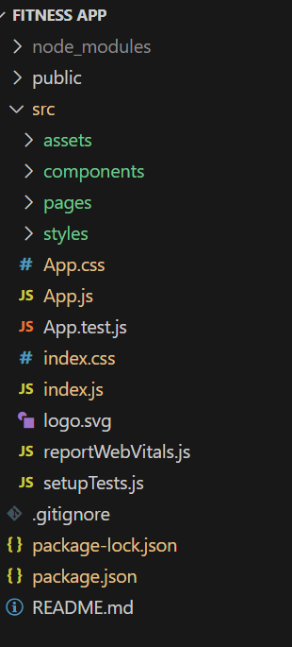

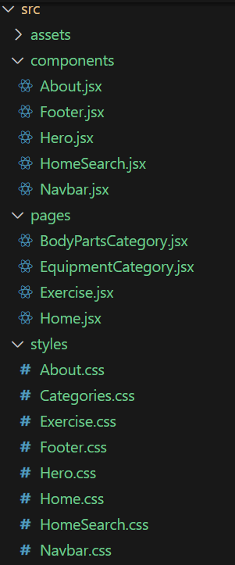

**6. Running the Application**

* **Start development server:**
* npm start
* **Build for production:**
* npm run build
* **Run tests:**
* npm test

**7. Component Documentation**

**Key Components**

* **Navbar.jsx** — Top navigation with app links.
* **Hero.jsx** — Intro section with video background.
* **HomeSearch.jsx** — Allows searching workouts.
* **Footer.jsx** — Contains links and copyright.
* **About.jsx** — App description section.

**Pages**

* **Home.jsx** — Displays Hero, About, and categories.
* **BodyPartsCategory.jsx** — Shows workouts filtered by body part.
* **EquipmentCategory.jsx** — Shows workouts filtered by equipment.
* **Exercise.jsx** — Displays instructions, exercise details, and YouTube videos.

**8. State Management**

* **Local State:**
  + Search queries stored in HomeSearch.
  + API data fetched and stored per-page.
* **Global State:** Not implemented — app uses component-level state.

**9. User Interface**

* **Pages include:**
  + Home (Hero + Search + About)
  + 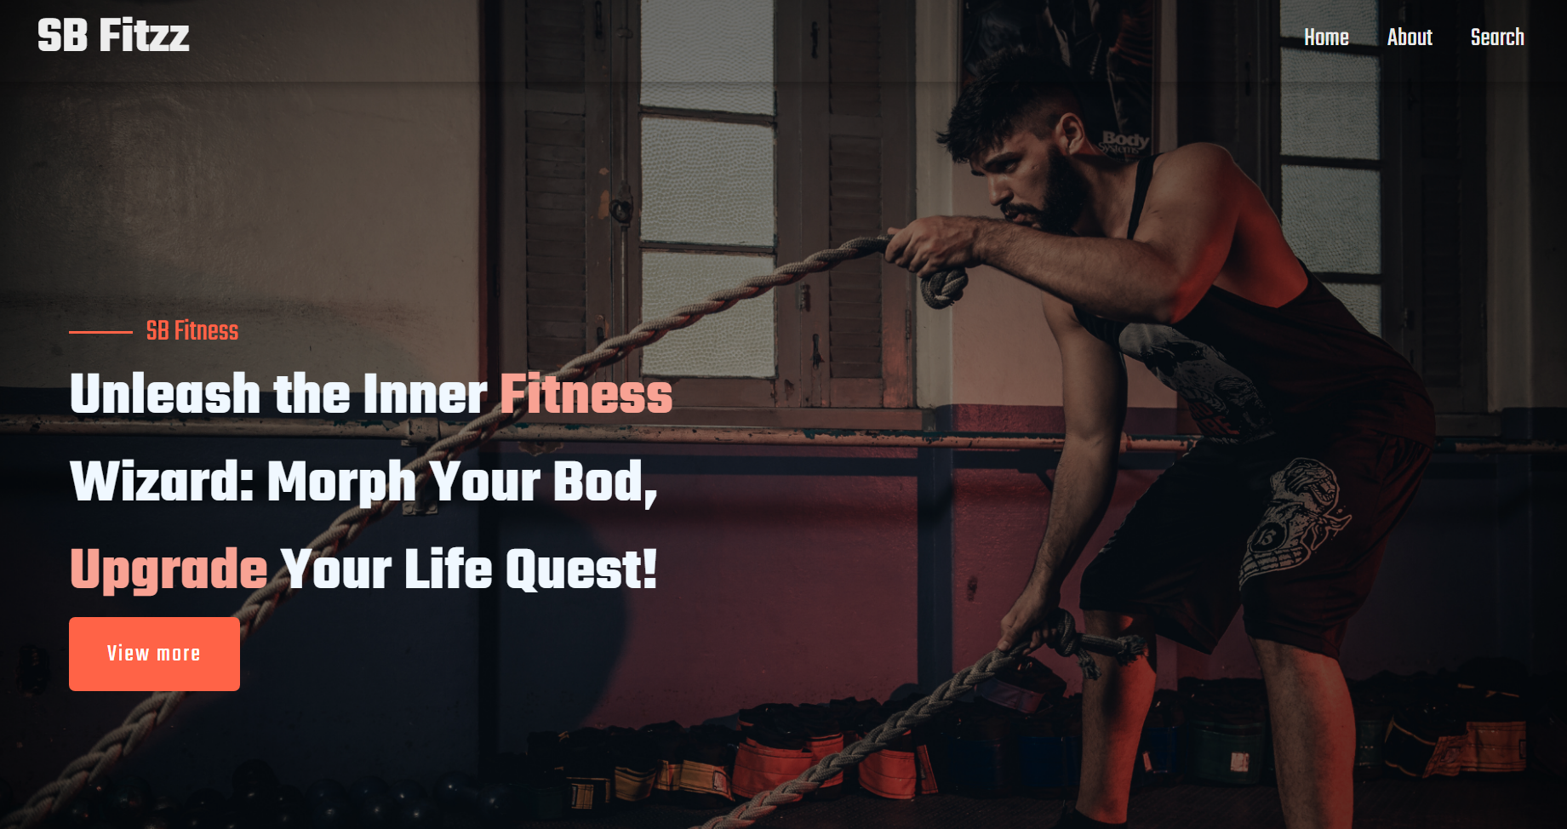
  + Category Pages (Exercises by filter)
  + 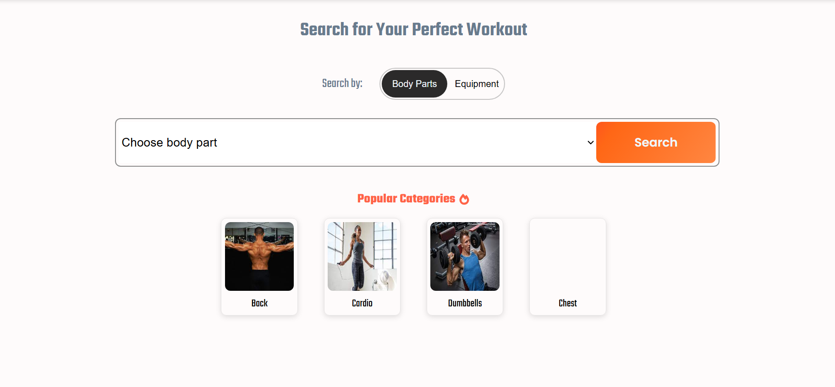
  + Exercise Detail (Steps + YouTube videos)
  + 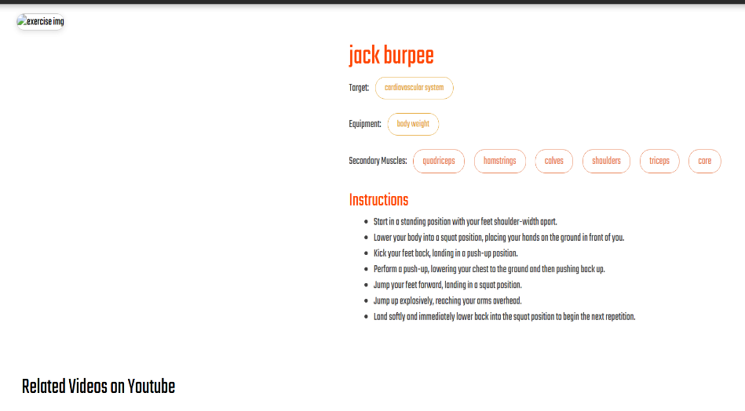

**10. Styling**

* **Frameworks Used:** Tailwind CSS / Bootstrap.
* **Custom CSS:** Stored in src/styles/.
* Each page/component has a dedicated CSS file for modularity.

**11. Testing**

* **Libraries Used:** Jest, React Testing Library.
* **Unit Tests:** Written in App.test.js.
* **Setup:** Configured with setupTests.js.

**12. Screenshots / Demo**

* **Demo Link:** <https://drive.google.com/file/d/1mUEZRmCsz84WlFlsNe5cZjCSjzttT0_m/view?usp=sharing>
* Screenshot:
* 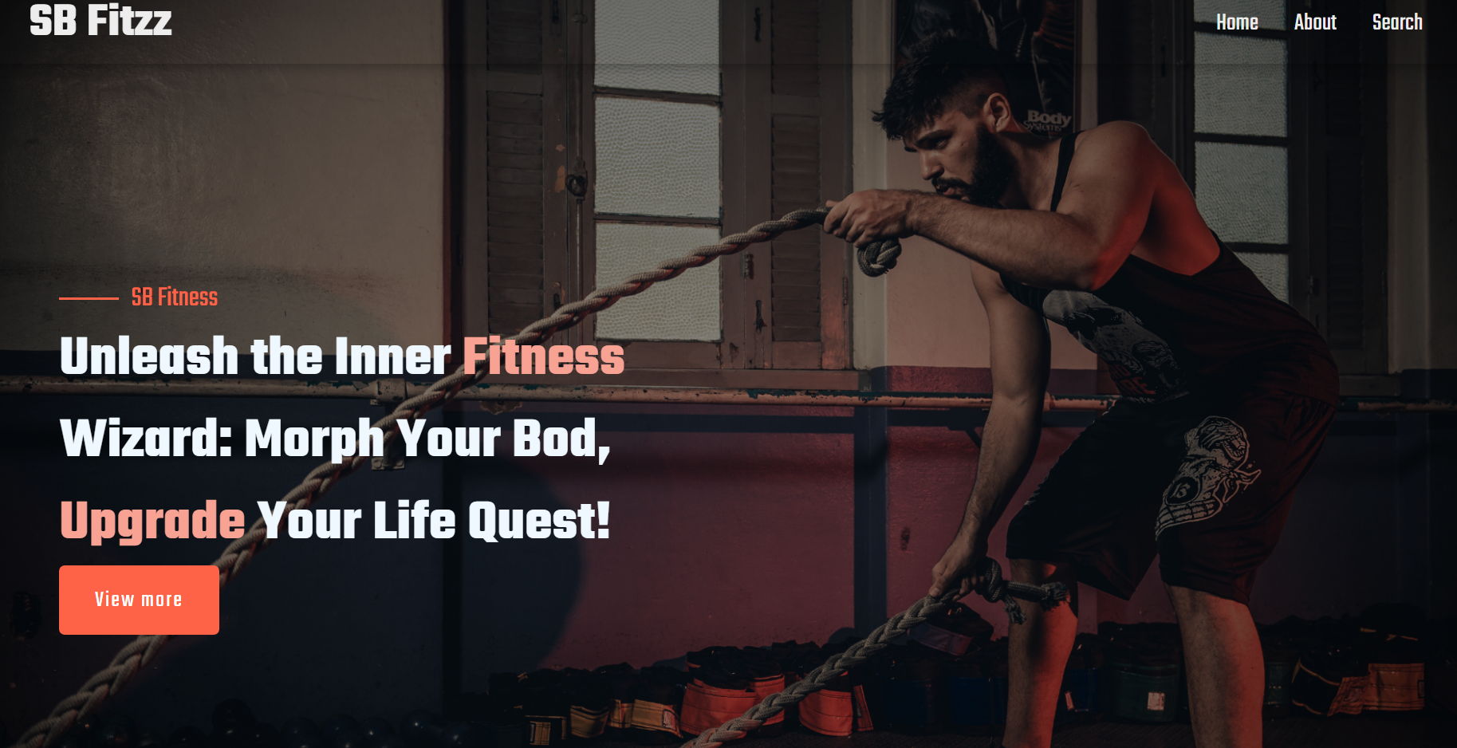

**13. Known Issues**

* API rate-limit may cause some exercises not to load.
* YouTube API sometimes fails to fetch related videos.

**14. Future Enhancements**

* Add login and user profile.
* Save favorite workouts.
* Add workout progress tracking.
* Implement offline caching with service workers.
* Enhance animations and transitions.